MSSE 500 - Week 6 Assignment

Name: David Freeman

Date: Oct-8-2017

I. Assignment Name: Build and/or Modify: Monkey Robot Pirate Ninja Zombie

II. Learning Objectives: (here is an example)

* Be able to integrate graphics, pop-ups, and sounds in order to create an interactive game/webpage.
* Understand array formation and arrays of arrays use for programming rules.

III. Abstract -

This week I made a moropinzee game, similar to rock paper scissors. I took the provided code from Meyer, 2010, chapter 8 and began modifying to allow for five different selections for the player and computer. The images I used came from [*https://openclipart.org/*](https://openclipart.org/)and the sound effects from [*https://freesound.org/browse/tags/sound-effects/*](https://freesound.org/browse/tags/sound-effects/). To let the player know if the had won or lost the round I had to change the points and beats arrays. This took me a bit to figure out and once I did I had them backwards, a victory would display the wrong message and deduct a point, I had made the arrays from the perspective of the player instead of the computer. Once corrected the game worked properly. Another error was that the image of the computer’s choice was shown as ‘growing’ using an interval, if the player tried to make a selection before the interval was cleared, it would never clear and the image would continue to grow and the sound effect play in an infinite loop until the page was reloaded. I took out the interval to avoid this.

IV. Statement of Originality

For this game I started with the provided code from GitHub and began to modify the original code in order to add allow for the play of moropinzee instead of just Rock Paper Scissors. The clip art and sounds were found using a Google search.

[*https://openclipart.org/*](https://openclipart.org/)

[*https://freesound.org/browse/tags/sound-effects/*](https://freesound.org/browse/tags/sound-effects/)

1V.

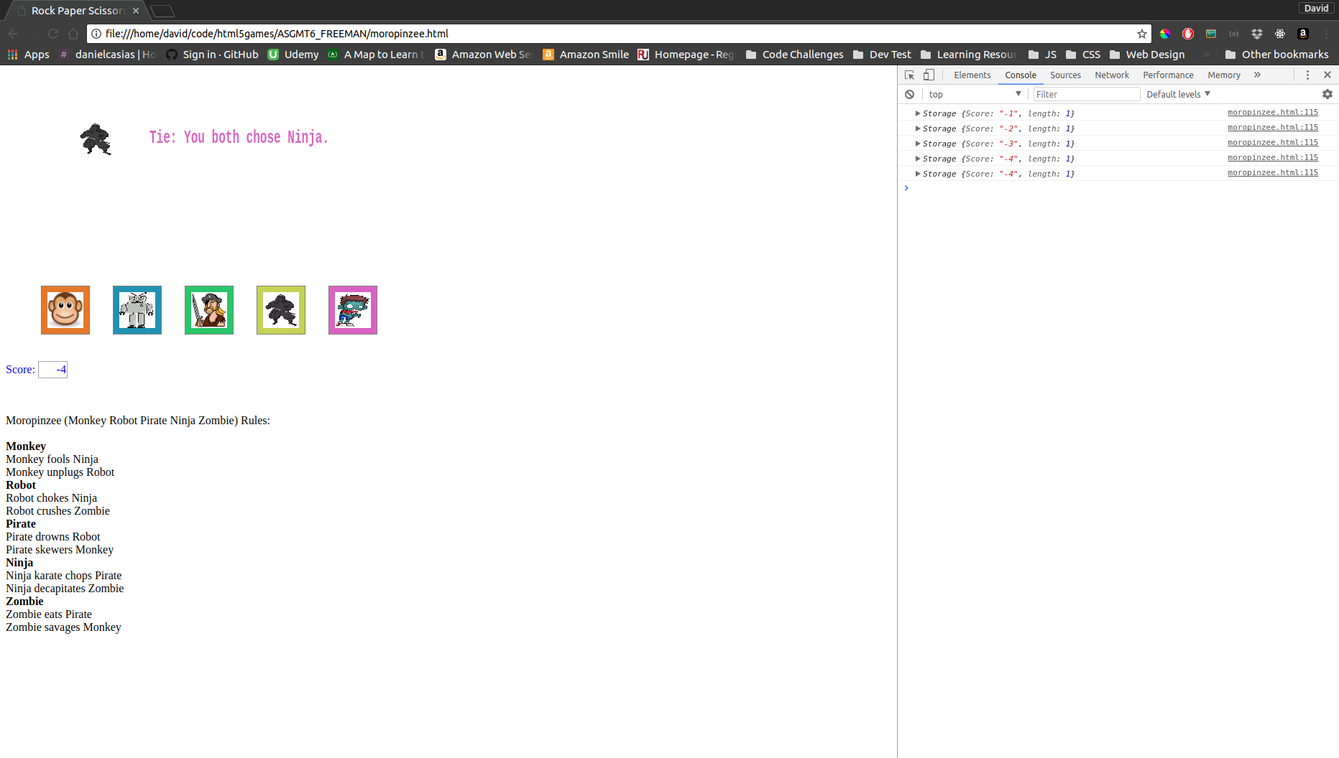

*Figure 1: Screenshot of Moropinzee*

VI.

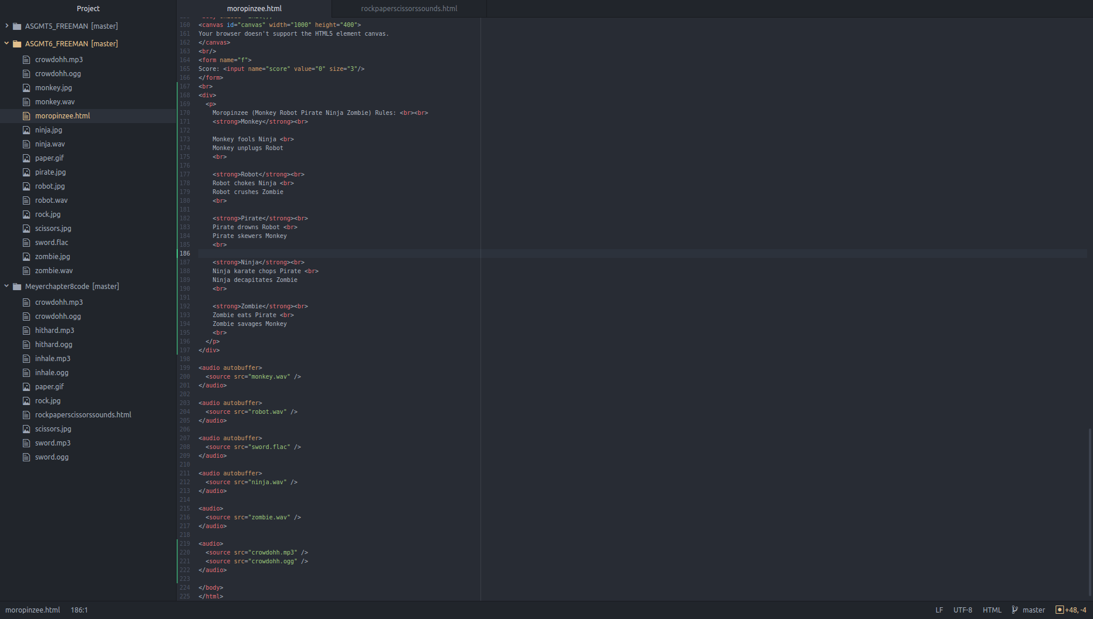

*Figure 2: Screenshot of code for moropinzee.html*

*Note: Original code from Meyer, 2010, chapter 8 rockpaperscissorssounds.html*